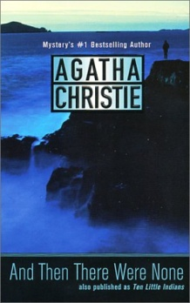
Honors English I
Learning Guide
Unit #1:
Summer Reading Assignment
And Then There Were None
SELF-ASSESSMENT |  |  |  | Use these to score yourself:
Student | Teacher | Learning Targets |  | 4 | I understand it, I can do it, and I can comfortably explain it to another learner.
 |  | I can analyze character relationships and how they develop, by writing a complete five-paragraph essay. RL.9.3, W.9.10 |  | 3 | I am confident that I understand it and think I can use it in my learning.
 |  | I can read and comprehend classic literature. RL.9.10 |  | 2 | I am not quite there yet. I still have questions, and I need help figuring them out.
 |  | I can explain the Socratic method and be prepared to use it in the future. SL.9.1 |  | 1 | I need a lot of help, and I am confused about what I am supposed to do.
 |  | I can write for a range of tasks, purposes, and audiences. W.9.10
 |  | I can determine and clarify the meaning of words and phrases, and I can acquire and use accurately academic and domain-specific words and phrases. L.9.4,6

KEY VOCABULARY | Definition | Example | Expression
analyze
alliances
motivation
interpretation
thesis
Socratic Method

ASSESSMENT CRITERIA
Completed five paragraph essay (rubric below)
Unit Test on And Then There Were None

Five Paragraph Essay
Is this paper double-spaced?
Is this paper typed using 12pt Times New Roman font?
Does the introduction have a topic statement/thesis?
Does the paper focus on alliances between the characters listed on the Summer Assignment?
Does the paper discuss how the alliance affects actions in the story?
Does the paper draw conclusions how the alliances help and / or hurt the murderer?
Does this paper use support from the story in the form of concrete detail and commentary?
Does the paper use sufficient transitions between paragraphs 2-5?
Is this paper free from errors in sentence structure, spelling, and punctuation?
Does the paper have the minimum number of words in each paragraph?
Final Grade Out of 100
Part 2: Unit Test
Multiple Choice Response
Worth 100 Points
Final Grade Out of 100

