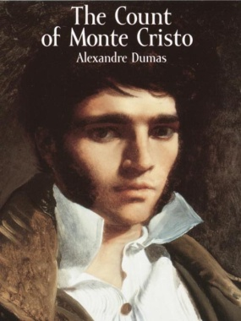
Honors English I
Learning Guide
Unit #3:
Literary Analysis
The Count of Monte Cristo

SELF-ASSESSMENT |  |  |  | Use these to score yourself:
Student | Teacher | Learning Targets |  | 4 | I understand it, I can do it, and I can comfortably explain it to another learner.
 |  | I can use the blueprint structure in order to write an analysis of a literary text. W.9.1-3 |  | 3 | I am confident that I understand it and think I can use it in my learning.
 |  | I can write formally and informally to make my writing appropriate for each task and audience by controlling by diction and syntax. W.9.4, 10 |  | 2 | I am not quite there yet. I still have questions, and I need help figuring them out.
 |  | I can respond thoughtfully to others’ perspectives by evaluating what they say, reasoning, discussing, and responding. SL.9.1,3 |  | 1 | I need a lot of help, and I am confused about what I am supposed to do.
 |  | I can develop a claim or counterclaim based on factual evidence. SL.9.4
 |  | I can write informative and explanatory texts in response to non-fiction informational texts. W.9.2
 |  | I can write a narrative in the form of a melodrama. W.9.3
 |  | I can determine and clarify the meaning of words and phrases, and I can acquire and use accurately academic and domain-specific words and phrases. L.9.4,6
 |  | I can demonstrate command of the conventions of English grammar, usage, capitalization, punctuation, and spelling. L.9.1-2

KEY VOCABULARY | Definition | Example | Expression
diction
syntax
perspective
claim
counterclaim
informative/
explanatory
sequence
of events
narrative
melodrama

ASSESSMENT CRITERIA
Unit test on The Count of Monte Cristo
Completed original melodrama with dialogue
Completed independent novel poster presented and displayed

