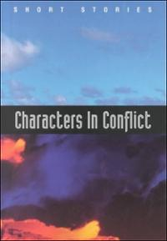
Honors English I
Learning Guide
Unit #4:
The Short Story &
Its Supporting Informational Text
SELF-ASSESSMENT |  |  |  | Use these to score yourself:
Student | Teacher | Learning Targets |  | 4 | I understand it, I can do it, and I can comfortably explain it to another learner.
 |  | I can determine a theme or central idea of a text and analyze its development over the course of the text. RL.9.2 |  | 3 | I am confident that I understand it and think I can use it in my learning.
 |  | I can diagram the events in a story using the Freytag Pyramid and identify all of its parts. RL.9.5 |  | 2 | I am not quite there yet. I still have questions, and I need help figuring them out.
 |  | I can read and comprehend fictional and non-fictional literature. RL.9.10 & RI.9.10 |  | 1 | I need a lot of help, and I am confused about what I am supposed to do.
 |  | I can determine the meaning of words and phrases as they are used in an informational text. RI.9.4
 |  | I can analyze in detail how an author’s ideas or claims are developed and refined by particular sentences, paragraphs, or larger portions of a text. RI.9.5
 |  | I can write an original narrative to develop a real or imagined experience. W.9.3
 |  | I can write for a range of tasks, purposes, and audiences. W.9.10
 |  | I can present multiple sources of information using diverse media or formats—including digital media—strategically. SL.9.2-5
 |  | I can come to a decision through discussing, reasoning, evaluating, and responding. SL.9.1,3

KEY VOCABULARY | Definition | Example | Expression
theme
central idea
Freytag Pyramid
exposition
initial incident
rising action
climax
falling action
resolution
denouement

ASSESSMENT CRITERIA
Pre-test for Literature
Literary response prompts in blueprint paragraph form
Independent novel presented digitally and orally
Recreate the Freytag Pyramid
Unit test on short stories

