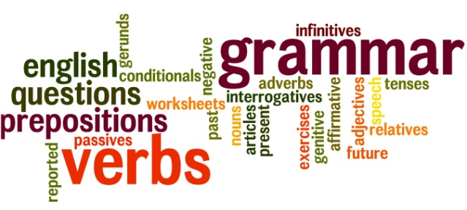
Honors English I
Learning Guide
Unit #5:
Grammar
SELF-ASSESSMENT |  |  |  | Use these to score yourself:
Student | Teacher | Learning Targets |  | 4 | I understand it, I can do it, and I can comfortably explain it to another learner.
 |  | I can write simple sentences with compound subjects, compound predicates, noun phrases and prepositional phrases. L.9.1 |  | 3 | I am confident that I understand it and think I can use it in my learning.
 |  | I can write compound sentences by using independent clauses with coordinating conjunctions, conjunctive adverbs, or semicolon. L.9.1 |  | 2 | I am not quite there yet. I still have questions, and I need help figuring them out.
 |  | I can write complex sentences by using adverb clauses with subordinate conjunctions and adjective clauses with relative pronouns L.9.1. |  | 1 | I need a lot of help, and I am confused about what I am supposed to do.
 |  | I can use correlative conjunctions correctly. L.9.1
 |  | I can demonstrate command of the conventions of English capitalization, punctuation, and spelling. L.9. 2
 |  | I can differentiate between words that are often confused in the English language. L.9.4,6

KEY VOCABULARY | Definition | Example | Expression
subject
predicate
compound
noun phrase
prepositional phrase
independent clause
coordinating conjunction
conjunctive adverb
semicolon
adverb clause
subordinating conjunction
adjective clause
relative pronoun
correlative conjunction

ASSESSMENT CRITERIA
Completed business letter
Often Confused Words worksheets
Blueprint paragraphs
Unit test

