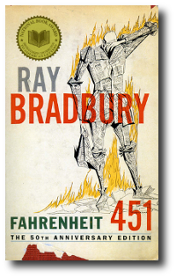
Science Fiction/Fantasy English IV
Learning Guide
Unit #9:
Dystopian Literature
Short Stories and Fahrenheit 451

SELF-ASSESSMENT |  |  |  | Use these to score yourself:
Student | Teacher | Learning Targets |  | 4 | I understand it, I can do it, and I can comfortably explain it to another learner.
 |  |  |  | 3 | I am confident that I understand it and think I can use it in my learning.
 |  |  |  | 2 | I am not quite there yet. I still have questions, and I need help figuring them out.
 |  |  |  | 1 | I need a lot of help, and I am confused about what I am supposed to do.

KEY VOCABULARY | Definition | Example | Expression

ASSESSMENT CRITERIA

