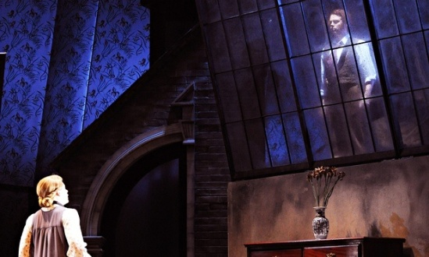
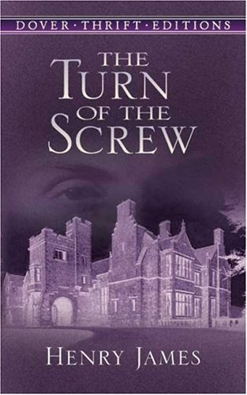
Honors English I
Learning Guide
Unit #5:
Author Exploration
The Turn of the Screw

SELF-ASSESSMENT |  |  |  | Use these to score yourself:
Student | Teacher | Learning Targets |  | 4 | I understand it, I can do it, and I can comfortably explain it to another learner.
 |  | I can analyze the representation of a subject using two different artistic mediums. RL.9.7 |  | 3 | I am confident that I understand it and think I can use it in my learning.
 |  | I can analyze how an author draws on and transforms source material into a specific work. RL.9.9 |  | 2 | I am not quite there yet. I still have questions, and I need help figuring them out.
 |  | I can read and comprehend fictional literature. RL.9.10 |  | 1 | I need a lot of help, and I am confused about what I am supposed to do.
 |  | I can analyze important historical documents for how the author addresses themes and concepts. RI.9.9
 |  | I can write an argument to support my claim in an analysis of a literature topic. W.9.1
 |  | I can write for a range of tasks, purposes, and audiences. W.9.10
 |  | I can determine and clarify the meaning of words and phrases, and I can acquire and use accurately academic and domain-specific words and phrases. L.9.4,6
 |  | I can come to a decision through discussion, reasoning, evaulating, and responding. SL.9.1,3
 |  | I can adapt my speech to a variety of contexts and tasks. SL.9.6

KEY VOCABULARY | Definition | Example | Expression
New Criticism
foreshadowing
personification
caricature
author’s purpose
epithet
paradox
apparition
novella

ASSESSMENT CRITERIA
Do I believe in Ghosts
Written response to “New Criticism” article
Unit test on The Turn of the Screw
Completed five-paragraph essay reflecting opinion about The Turn of the Screw (unit #6 multi-paragraph PP)

