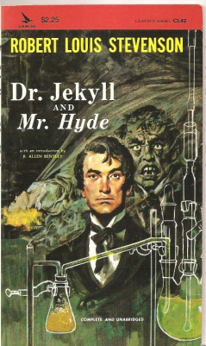
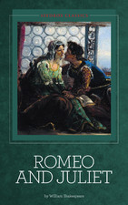
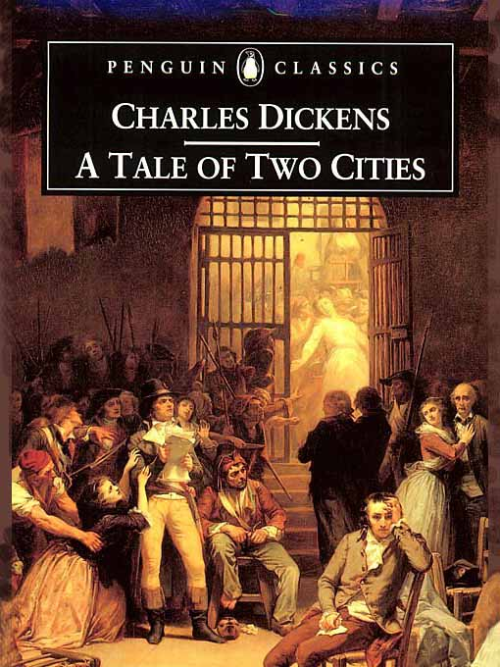
Honors English I
Learning Guide
Unit #8:
Character Analysis
Dr. Jekyll and Mr. Hyde,
Romeo and Juliet and A Tale of Two Cities

SELF-ASSESSMENT |  |  |  | Use these to score yourself:
Student | Teacher | Learning Targets |  | 4 | I understand it, I can do it, and I can comfortably explain it to another learner.
 |  | RL.9.3 I can analyze how complex characters develop, interact with other characters, and advance the plot over the course of a text. |  | 3 | I am confident that I understand it and think I can use it in my learning.
 |  | RL.9.10 I can read and comprehend literature |  | 2 | I am not quite there yet. I still have questions, and I need help figuring them out.
 |  | W.9.10 I can write for a range of tasks, purposes, and audiences. |  | 1 | I need a lot of help, and I am confused about what I am supposed to do.
 |  | SL.9.1,3 I can come to a decision through discussion, reasoning, evaulating, and responding.
 |  | SL.9.6 I can adapt my speech to a variety of contexts and tasks.
 |  | L.9.4,6 I can determine and clarify the meaning of words and phrases, and I can acquire and use accurately academic and domain-specific words and phrases.

KEY VOCABULARY | Definition | Example | Expression
complex
develop
interaction
plot
tragedy
imagery
the human condition
sonnet
prologue
epilogue

ASSESSMENT CRITERIA
Unit test on Romeo and Juliet
Unit test on A Tale of Two Cities
Original Eulogy
Unit test on Dr. Jekyl and Mr. Hyde

