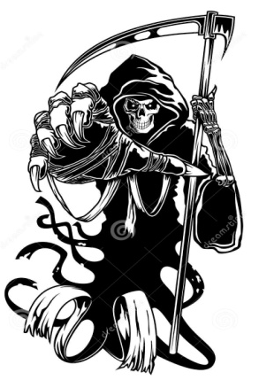
Science Fiction/Fantasy English IV
Learning Guide
Unit #1:
Horror Short Stories
& Informational Text
SELF-ASSESSMENT |  |  |  | Use these to score yourself:
Student | Teacher | Learning Targets |  | 4 | I understand it, I can do it, and I can comfortably explain it to another learner.
 |  | I can identify structure of events in a text. |  | 3 | I am confident that I understand it and think I can use it in my learning.
 |  | I can write a story with elements of plot. |  | 2 | I am not quite there yet. I still have questions, and I need help figuring them out.
 |  | I can write a story using dialogue. |  | 1 | I need a lot of help, and I am confused about what I am supposed to do.
 |  | I can identify the literal meaning of a story.
 |  | I can analyze the interpretive meaning of a story.
 |  | I can analyze the deeper meaning of a short story by applying it to my own life.

KEY VOCABULARY | Definition | Example | Expression
dialogue | conversation between two or more people as a feature of a book, play, or movie.
exposition | the part of a story in which the theme and main characters are introduced; situation that opens the story
rising action | builds the tension of the story and adds to and complicates the conflict
denouement | Results from the climax of the story and brings the story to its resolution.
climax | the point at which the tension of the conflict is greatest
resolution | Occurs when the conflict is solved and all struggles are ended.

ASSESSMENT CRITERIA

